Week3 lab02 Relational Data Model
Name: Chey Naryevty
ID: IDTB110199
Human Resource (HR)
Entity sets: employees, em_resigns, jobs, departments, locations, regions, country
- employees (strong)
  - id (PK)
  - name
  - phone_num
  - email
  - salary
  - manager
  - comissions
  - hired date
  - em_resign (FK)
  - job_id (FK)
  - department_id (FK)
- em_resign (weak)
  - start_date
  - end_date
  - em_id (PK)
- jobs (strong)
  - id (PK)
  - title
  - salary_range
i. min ii. max
- departments (strong)
  - dep_num (PK)
  - manager
  - location_id (FK)
- locations (strong)
  - id (PK)
  - street_name
  - postal_code
  - city_sate/province
  - country_id (FK)
- regions (weak)
  - id (PK)
  - name
- countries (strong)
- name
- id(PK)
- regions_id (FK)
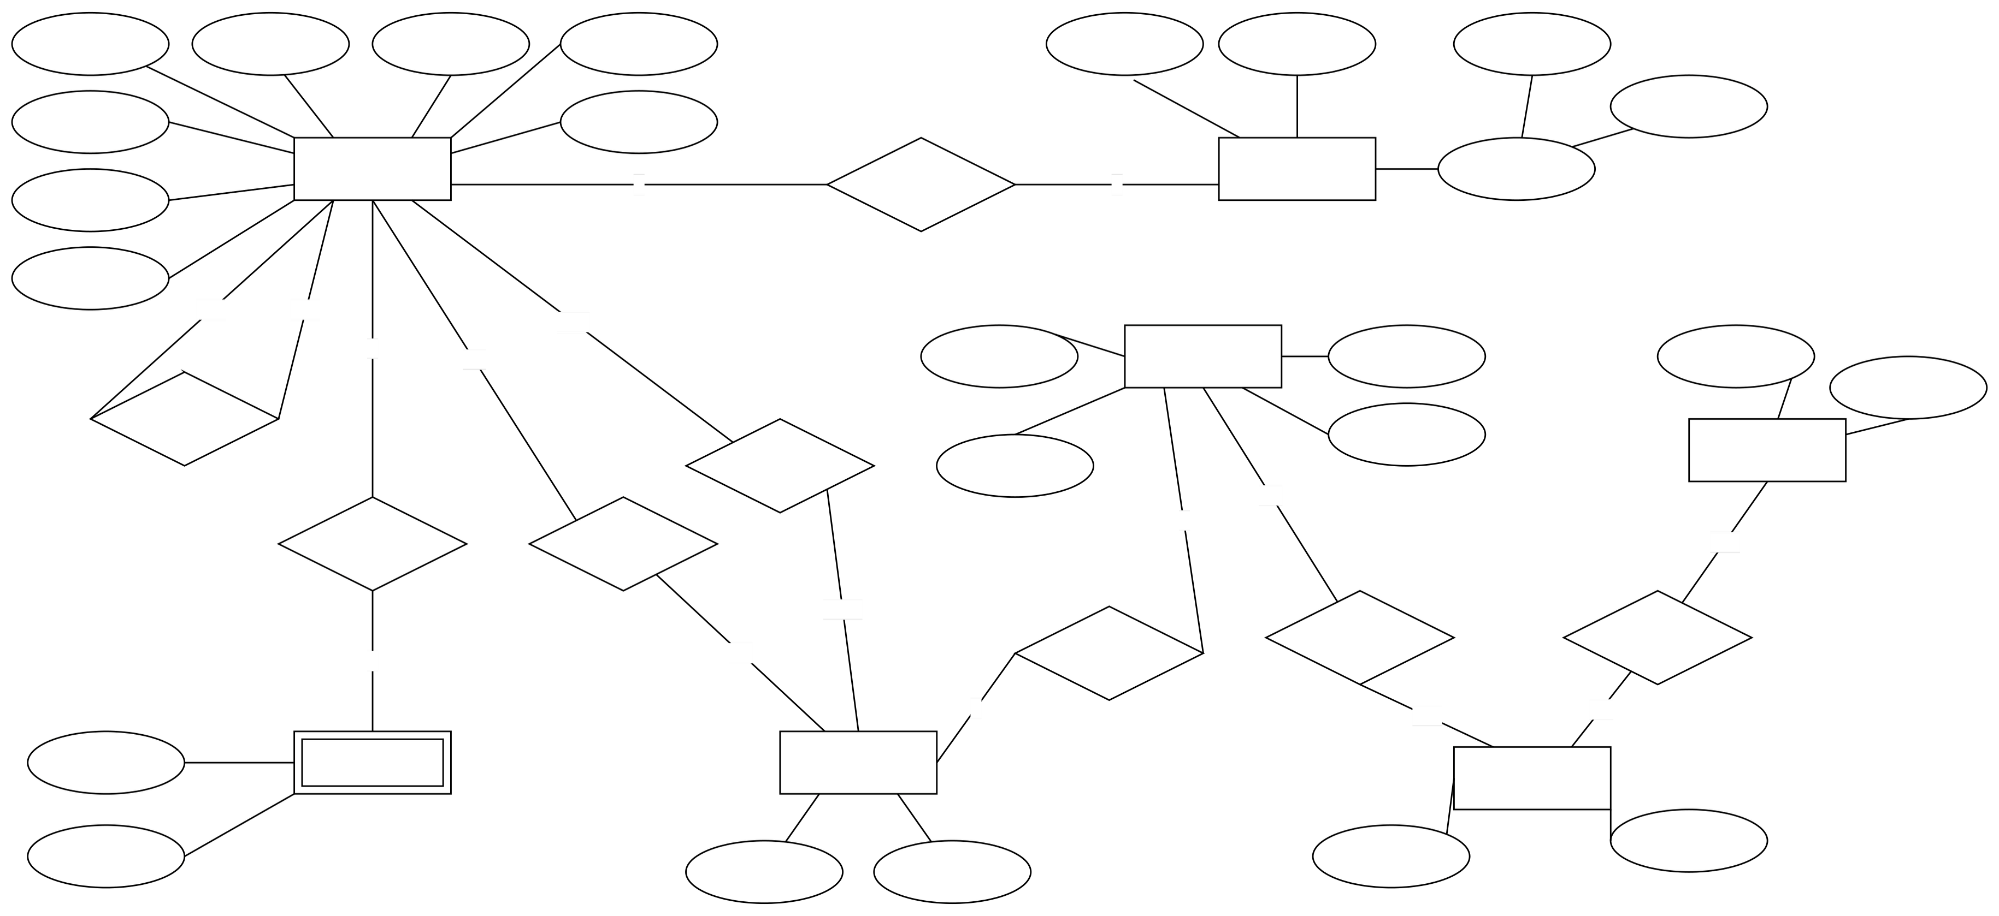
email
phone_num
hired_date
comissions
end_date
start_date
mangae
id
has
em_resign
employees
name
manage
salary
manager
dep_num
work_for
departments
works_as
manager
id
postal_code
title
located_at
locations
id
jobs
located_at
name
street_name
city_state/province
max
salary_range
countries
id
min
located_at
name
regions
id
1

1:
M
1:
1
1
1:1
1
:
1
1
1:1
1
: M
1
1
1
1:1
1:
M
1:1
1:
M
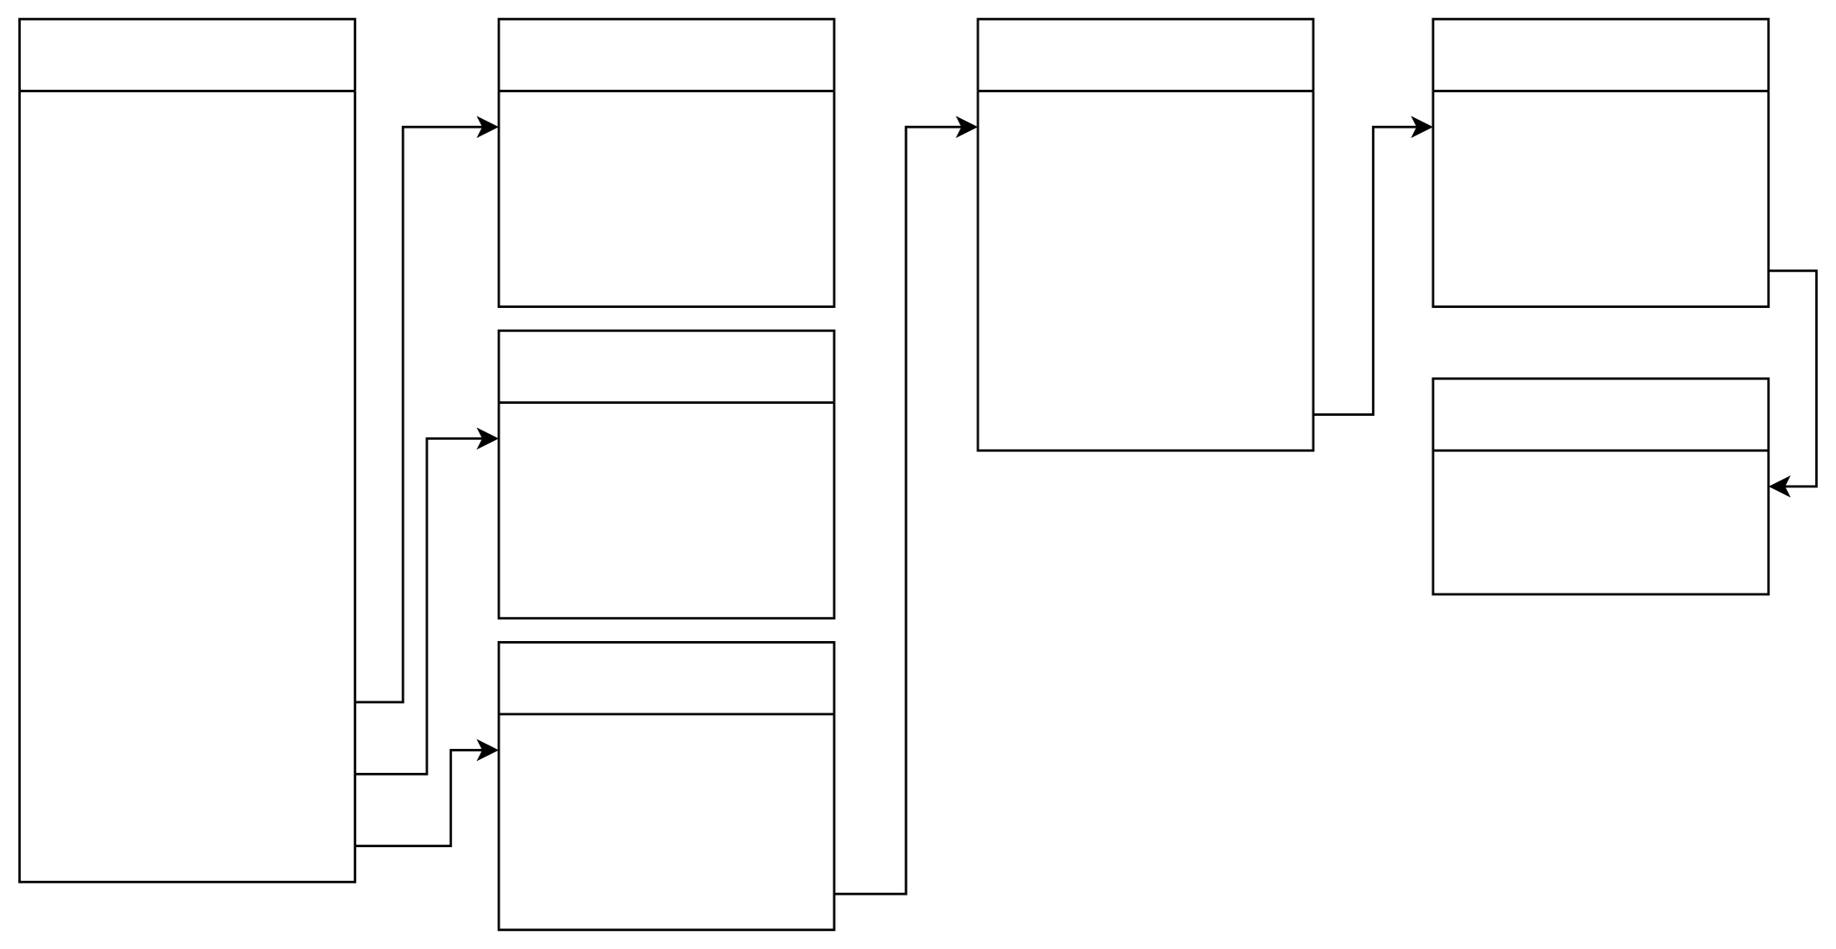
employees
id (PK)
name
phone_num
email
salary
manger
comission
hired_date
job_id (Fk)
em_resign_id (FK)
department_id (FK)
id (PK)
title
salary
jobs
em_resign
id (PK)
start_date
end_date
department
dep_num (PK)
manager
location_id (FK)
locations
id (PK)
street_name
postal_code
city_state/province
country_id (FK)
id (PK)
name
region
countries
id (PK)
name
regions_id (FK)

